Final Report
Group 2 – ICT30001

Student Number | Student Name
103487172 | Phan Nhật Minh
103488036 | Nguyễn Việt Trung
103806560 | Phan Ngọc Hải
104061221 | Bùi Việt Hoàng
103809802 | Hoàng Minh Đức

Modification History
Table 1.0 Modification History
Date | Modifications | Reason | Version
21/11/2024 | All detail of project |  | 1

Contents
Executive Summary 5
1. Introduction 6
1.1 Document Purpose 6
1.2 About Project 6
1.3 Document Scope 6
1.4 Terminology Used 7
1.5 Related Documents 7
1.6 Document Overview 8
2. Product Overview 9
2.1 Introduction 9
2.2 Business Services Supported 9
2.3 Solution Characteristics 10
2.3.1 User Interface 10
2.3.2 Hardware Interfaces 10
2.4 User Characteristics 10
2.4.1 General User Characteristics 10
2.4.2 System Access 11
2.5 General Constraints 11
3. Functional Requirements 12
3.1 Add New Client 13
3.2 Add Client Job Details 15
3.3 Add Item Codes 16
3.4 Create Quote Summary 19
3.5 Create Trade Summary 24
4. User Interface Requirements 31
4.1 Usability Requirements 32
5. Non-Functional requirements 33
5.1 Runtime Qualities 33
6. Acceptance Criteria 33
References 34
Glossary 34
Index 36
Purpose of Appendices 36
Appendix A: External Context Model 37
Appendix B: Internal Context Model 38
Appendix C: Use Case Analysis Notes 39
Appendix D: Development Process 40
Appendix E: Contributions 42
Appendix F: Meeting Agendas/Minutes 44
Appendix G: Problem Investigation Reports 45

Executive Summary
- The executive summary provides an outline of the KSE Software JSC project plan which involves developing an Office Rental Website for JSE Software Company. JSE Software Company was officially created in 2016 and later became well-known for its capable software development and expansive IT Services around the globe. Even though the company has been operating efficiently for a long time, there are a lot of problems that our team noted the further we looked. The company is facing challenges in managing its office rental due to the lack of a streamlined system and the lack of secure user authentication, a role-based system, and a notification system which may lead to many vulnerabilities and challenges. In addition, we have created the scope of the project that can answer these problems, which is the developed website can be accessed by login via email. Also, only the highest authorized account which is Super Admin can be able to set and manage admin roles. Instant notifications such as rental due or alerts can be sent to users and users can send and receive messages to each other within the platform. Users can also edit information such as profile images, and change email addresses or passwords,… Several key findings were discovered during our project development, by adopting an e-mail-based login and account verification system which will improve user authenticity and assure the privacy of its users. At the same time, this OTP verification system increases security. While the role-based access control system ensures that only authorized personnel manage data. This robust control system is very effective in maintaining the confidentiality of sensitive information. Furthermore, restricting the creation of admin accounts to trusted people increases data integrity and ensures that operations can run smoothly. Therefore, these components can make the website a more secure and dependable base for further expansion.

1. Introduction

1.1 Document Purpose
  - The purpose of this document is to outline the objectives, strategies, frameworks, and overall information of our Office Rental Website Development for KSE Software JSC Company. This report will serve as a comprehensive and detailed guide for our mentor – Mr. Nguyen Van Tang and our representative client – Ms. Nguyen Thi Van Anh which will ensure everyone has a clear understanding of goals, insights, and expectations. This document is also made to guide and keep track of our team members, helping to align closely to the client’s requirements and making sure all of the decisions and actions that are made throughout the development are consistent with our overall goal. Further ongoing improvements and plans will be mentioned. This report also shows our commitment and desire to refine the platform and satisfy our client’s needs, delivering a high-quality product to KSE Software Company.

1.2 About the Project
  - Our main objectives of the KSE Software JSC project are creating a user-friendly interface for login with an assurance that the platform will perform responsively and be accessible for users. Website optimization for quick response and lower downtime are vital for a good user experience. The website security will be enhanced by implementing OTP code verification via email account so unauthorized access can be limited. Features are provided to the highest authority personnel - Super Admins, using a role-based access control system which only Super Admins can be able to manage and set other admins roles. A messaging system will be implemented so all admins can communicate and collaborate. Lastly, each user will have their own profile space which they can edit and update personal information with accurate and up-to-date details.

1.3 Document Scope
  - This document contains a complete overview of the Office Rental Website about KSE Software JSC project design, development, and implementation. It will give a detailed description of the project goals, features, and technologies involved. It will define what the functional and non-functional requirements of the website are, for example, user management functionalities, security measures as well as performance indicators. The project document will start with an introduction to the project, covering its objectives and scope. It will also outline the user-interface requirements to ensure that the website works for all user types, avoiding low levels of usability. Furthermore, the document will provide a detailed breakdown of the system’s performance expectations, such as response times, security protocols, and reliability standards, under the section dedicated to non-functional requirements. This document will also include an explanation of the general constraints, access requirements, and system characteristics that define the platform’s architecture and user experience.

1.5 Related Documents
  - - Project Description Statement
  - - Initial Project Proposal
  - - Project Management Portfolio

1.6 Document Overview
  - This document will provide an outline that contains information on an office rental website development for KSE Software JSC. It includes:

  - Objectives:
  - - Create a user-friendly interface for login.
  - - Ensure the platform is responsive and accessible.
  - - Optimize for quick response times and lower downtime.
  - - Provide features for the super admin to manage other admins’ roles, send alerts to others
  - - Let users manage their personal information, ensuring accurate and up-to-date profiles.
  - - Enhance login security by implementing OTP verification to reduce unauthorized access.
  - - Facilitate efficient admin communication with a user-friendly messaging system.
Scopes:
- - Admin Login.
- - Authorized Super Admin Accounts can grant admin access.
- - Role-based Access Control
- - Instant Notifications: Notify admins via web
- - Profile edit available
- - Implement OTP verification, sending a code to the user's registered email
- - Implement a secure messaging system with real-time notifications and message history.
Challenges
- - Network Issues.
- - Misunderstood Client Requirement.
- - Bad Time Management.
- - Outdated Data Collection.
- - Overwhelming Interface functions.
- - Resource Limitations.
- - Lack of Collaboration.
Solutions:
- - Other members will have backups in place if one member has issues.
- - Clarify requirements through regular client meetings and detailed documentation using Google Docs.
- - Create a detailed project timeline and prioritize tasks effectively using the Gantt Chart.
- - Use up-to-date databases and APIs, and verify data accuracy regularly.
- - Simplify the interface design and ensure the development team can handle the functions.
- - Optimize resource use and consider scaling back non-essential tasks.
- - Encourage team communication through meetings via Google Meet in specific time zones.

2. Solution Overview

2.1 Introduction
  - The goal of this project is to create an efficient account management system with features like role-based permissions and communication through a notification system. Key issues to address include improving the security of admin accounts. The final product is expected to enhance security, be user-friendly, and improve account management for businesses.

2.2 Business Services Supported
  - The business support service includes website management features:
  - - Account Management: Create and edit user information, including personal details, login credentials, and account settings.
  - - Role Management: Assign flexible permissions based on roles, with data access customized per role. This includes creating new roles, modifying existing roles, and assigning roles to users.
  - - Notification and Messaging: A notification page for all users and a messaging function to facilitate communication within the system. Notifications can be triggered by various events such as account changes, role updates, and security alerts.
  - - Security Service: User verification via email to ensure account authenticity. Once verified, users gain elevated permissions and access to advanced features. Additional security measures include OTP authentication.
  - - User-Friendly Interface: A simple, soft-colored design for easy use, ensuring that users can navigate the system intuitively.

2.3 Solution Characteristics

2.3.1 User Interface
    - The business, KSI Miss Nguyen Van Anh, has no strict demands for the user interface. Therefore, our task is to optimize the UI/UX design:
    - - Simple Interface: Basic functions are displayed, with intuitive buttons and actions. The design should minimize the number of clicks required to perform common tasks.
    - - Role Management System: Displays information relevant to each account's role, with an easy-to-use permission management system. This includes visual indicators for role-specific permissions and access levels.

2.3.2 Hardware Interfaces
    - - The system is compatible with all web browsers, ensuring accessibility across different platforms and devices.
    - - Compatible with MySQL servers and GitHub for database management and version control, respectively. This ensures that the system can handle large volumes of data and support collaborative development.

2.4 User Characteristics

2.4.1 General User Characteristics
The users are system administrators, including general managers and staff in various departments such as network admin, financial admin, production admin, etc.
- Technology Knowledge: Basic tech understanding required. Users should be comfortable with standard web applications and have a basic understanding of account and role management.
- Main Requirement: Ability to read and understand user documents to use the system effectively and manage roles accurately. Training materials and user guides should be provided to assist users in learning the system.

2.4.2 System Access

Function | System Action | Database Tables
Login | Validate credentials, assign roles, create session | users
Notifications & Messages | Verify recipients, store messages and notifications, fetch alerts or full messages | users, messages, notifications
Role-Based Permissions | Super Admin account creation, role configuration, enforce access control | users, roles
OTP Verification | Generate OTP, verify email, create JWT, invalidate tokens after logout | users, otp

Login Process
- User Input:
The user provides their username and password through the login interface.
- Database Query:
The system queries the MySQL database to validate the credentials from the user's table.
- Validation:
If the provided credentials match the stored records:
  - The system authenticates the user.
  - If the credentials are invalid, an error message prompts the user to re-enter valid data.
- Role Assignment:
After successful authentication, the system fetches the user’s role (e.g., admin, staff) from the database and maps it to the relevant permissions.
- Session Creation:
A secure session is initialized for the user. The session includes encrypted data to track user activity during their interaction with the system.

Notifications and Messages

Messages
- Recipient Validation:
  - The system verifies if the recipient's email matches a registered account in the user's table.
  - If a match is found, the message is prepared for delivery.
- Message Storage:
  - Completed messages are stored in two MySQL tables: notifications (for brief alerts) and messages (for detailed records).

Notifications
- Fetching Notifications:
  - Notifications can be accessed through two methods:
    - Notification Icon (Bell): When clicked, the system fetches data from the notifications table and displays concise messages.
    - View All Button: Redirects the user to a Messages Page, where the system fetches and displays complete messages from the messages table.

3. Role-Based Permissions
- Super Admin Setup:
  - A default Super Admin account is created using Postman to automatically populate the MySQL database with the necessary credentials and role assignments.
- Admin Roles and Permissions:
  - Permissions for all admin accounts are configured based on Table 1.0, which specifies the role hierarchy and associated actions.
  - The system enforces access controls by dynamically checking user roles during every system interaction.

4. OTP Verification with JWT
- Token Structure:
The system uses JSON Web Tokens (JWT), which consist of three securely hashed parts:
  - Header: Contains metadata about the token (e.g., type, algorithm).
  - Payload: Encodes the user’s identity and role.
  - Signature: Ensures the token's authenticity by hashing the header, payload, and a secret key.
- Secret Key:
  - The secret key is randomly generated and securely stored within the company’s infrastructure, ensuring it remains inaccessible to unauthorized entities.
- OTP Generation and Verification:
  - The system generates a 6-character OTP and stores it temporarily in the database.
  - The OTP is sent to the user's email using Nodemailer.
  - The user inputs the OTP, and the system verifies it against the stored value.
  - Upon successful validation, a JWT is created and sent to the user's browser for session management.
- Token Lifecycle:
  - The token is valid only for the session in use.
  - Upon logout, the system invalidates and deletes the token from memory to enhance security.

2.5 General Constraints
  - General constraints the system must handle include:
- Meeting all required functionalities as outlined in the project scope.
- Ensuring development and deployment are on schedule, with regular progress updates and milestone reviews.
- Storing data securely in MySQL, ensuring user data protection through encryption, regular backups, and compliance with data protection regulations.

3. Functional Requirements
Login System
- Validate Credentials:
  - The system must validate user credentials (email and password) during the login process.
  - Incorrect credentials should prompt an error message to the user.
- Assign Roles:
  - Upon successful login, the system must assign the appropriate role (e.g., Super Admin, Admin) to the user.
  - Role assignment should be based on predefined criteria set by the system administrators.
- Create Session:
  - The system must create a user session upon successful login.
  - User sessions should expire after a period of inactivity or upon user logout to ensure security.
Notifications & Messages
- Verify Recipients:
  - The system must verify the recipient’s identity before sending notifications or messages.
  - Notifications and messages should only be sent to valid and active users within the system.
- Store Messages and Notifications:
  - The system must store all sent and received messages and notifications in a secure database.
  - Users should be able to view their messages and notification history.
- Send Alerts or Full Messages:
  - The system should fetch and display alerts and full messages to users in real time.
  - Users should receive instant notifications for important events, such as rental decisions and account updates.
Role-Based Permissions
- Super Admin Account Creation:
  - Only authorized personnel (existing Super Admins) should be able to create new Super Admin accounts.
  - The system must ensure that Super Admin account creation follows a secure verification process.
- Enforce Access Control:
  - The system must enforce access control based on the assigned roles.
  - Users should only have access to functionalities and data that are permitted by their role.
OTP Verification
- Generate OTP:
  - The system must generate an OTP code and send it to the user’s registered email during registration or password recovery.
  - OTPs should be unique and expire after a short period to enhance security.
- Verify Email:
  - The system must verify the user’s email address by requiring the user to enter the OTP sent to their email.
  - Successful OTP verification should allow the user to proceed with registration or password recovery.
- Invalidate Tokens After Logout:
  - The system must invalidate the user’s JWT upon logout to ensure that the token cannot be reused.
Activity Diagram
Account System Flowchart
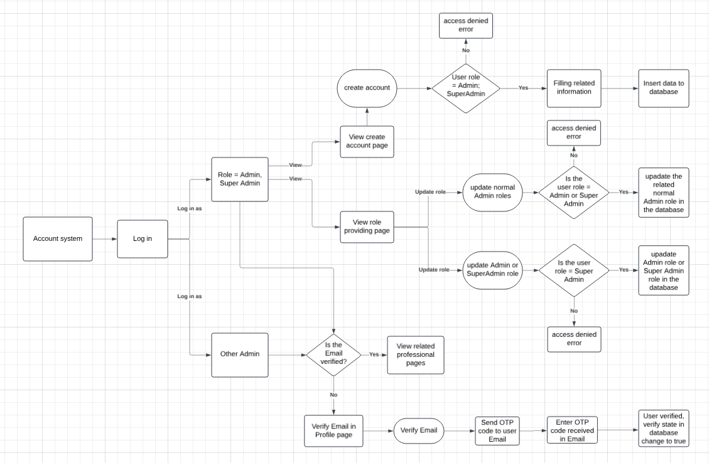

Notifications and Messages System Flowchart

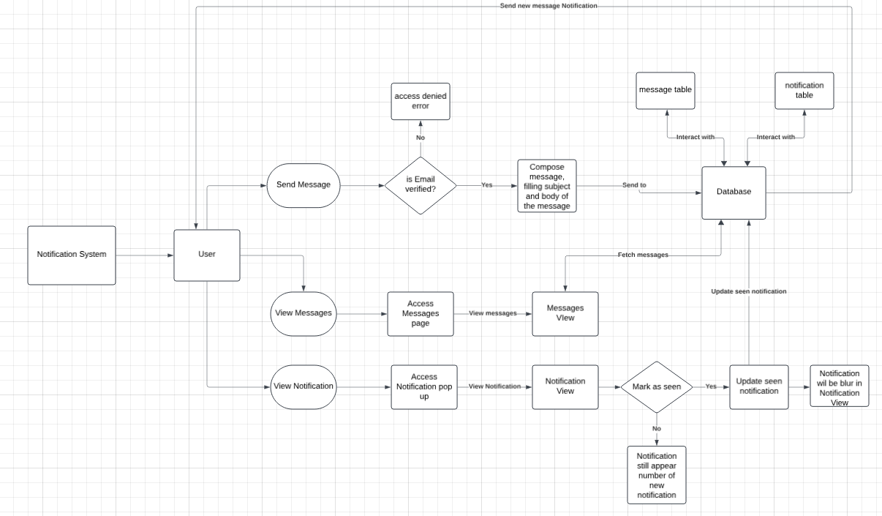

5. Non-Functional requirements
Performance:
- The system must handle concurrent access by multiple users without significant performance degradation.
- Page load times should not exceed 3 seconds under normal load conditions.
- The system must be able to handle peak loads with a maximum response time of 5 seconds.
Security:
- All user data must be encrypted in transit and at rest.
- The system must use secure protocols (e.g., HTTPS) for data transmission.
- Regular security audits and vulnerability assessments must be conducted.
Usability:
- The user interface should be intuitive and easy to navigate.
- The system must be responsive and accessible on various devices, including desktops, tablets, and smartphones.
- The design should follow established usability standards and best practices.
Reliability:
- The system must have an uptime of 99.9% excluding scheduled maintenance.
- Backup and recovery mechanisms must be in place to prevent data loss.
- The system should be able to recover from failures within 15 minutes.
Scalability:
- The system architecture must support future growth in terms of users and data volume.
- The system should be designed to scale horizontally to handle increased load.
Maintainability:
- The codebase should follow standard coding practices and be well-documented.
- The system must be modular to facilitate easy updates and maintenance.
- Regular maintenance schedules should be defined and followed.
Compliance:
- The system must comply with relevant data protection regulations.
- All user data handling practices must align with industry standards and legal requirements.
Compatibility:
- The system should be compatible with major web browsers (e.g., Chrome, Firefox, Safari, Edge).
- The platform must integrate seamlessly with third-party services for email verification and notifications.

6. Acceptance Criteria

References

Glossary
Table 4 Glossary terms
Term | Definition/Description
Admin | A user with elevated privileges to manage and control various aspects of the system.
Super Admin | A top-level administrator with permission to manage other admins, roles, and critical system configurations.
Role-Based Access Control (RBAC) | A system of managing user permissions based on their assigned roles within the application.
OTP (One-Time Password) | A unique, temporary password is sent to users for authentication, enhancing login security.
JWT (JSON Web Token) | A secure token is used to verify user identity and manage sessions.
Session | A temporary, secure state is maintained during a user's interaction with the system.
Notification | A brief alert is sent to users to inform them of events such as role updates, account changes, or messages.
Message | A detailed communication exchanged between system users is stored in the database for record-keeping.
Validation | The process of verifying user inputs (e.g., credentials, OTP) against stored data to ensure authenticity.
Encryption | The process of securing data by encoding it, ensuring only authorized parties can access it.
Database | A structured system for storing, managing, and retrieving data, such as user credentials and messages.
MySQL | A popular open-source relational database management system used to store and manage application data.
GitHub | A version control platform used to collaborate on and manage source code.
Nodemailer | A library used to send emails is often utilized for delivering OTPs to users.

Index
Students will need to complete this section of the document if it is longer than 30 pages.

Purpose of Appendices
Appendices are used to provide supporting material for the main document.
The first 2 appendices are normal supporting material.
The remaining appendices are included for educational reasons. They would not normally be included in a Software Requirements Specification.
Ensure that your rough work demonstrates the connection between the requirements described by this document and the analysis undertaken. You may wish to include a table that shows the connection.

Appendix A:

Appendix B:

Appendix C:

Appendix D: Development Process
You should describe all the various tasks that you have conducted as well as the various techniques that you have used in the development of this document. You need to describe all information that has been used as inputs for each of the tasks as well as the outputs produced.
[hint: review the tasks and activities associated with an SDLC]

Tasks Undertaken
Table 5 Tasks undertaken in the development of this document
Task Name | Description | Technique(s) Used

Task Name: The common name for this task.
Description: A short description of what was undertaken as part of this task.
Technique(s) Used: What techniques were used to complete this task?
Notes: The above table needs to be completed after the entire exercise has been planned/completed. Focus on writing down all the tasks that have been undertaken as part of this document engineering exercise as they are being conducted. An initial set of tasks can be identified early during the planning phase. The tasks should be based on the lecture material on the Requirements Elicitation and Specification activity.

Task Outputs
Table 6 Sections affected by the various tasks
Task Name | Outputs | Section(s)
Task 1 | Output 1 | 1.2, 1.4, 1.8
Task 1 | Output 2 | 5.3 – 5.6
Task 1 | Output 3 | 2.3, 7.0

Task Name: The common name for this task (from the table above).
Output(s): The outputs from the task carried out. Each of the various techniques used shall result in a different set of outputs (all outputs need not be substantiated with documents). For each output, clearly state which sections use the generated data.
Section(s): The section of the document that contains the output(s) from this task. It is expected that some tasks will produce outputs that are used in several sections of the document.
Notes:
- Follow the format in the example tables supplied above.
- If large tasks were broken down into smaller sub-tasks then show each of the sub-tasks.

Appendix E: Contributions
This section shall contain the names of all the contributors to this document. The sections that each contributor has worked on shall be described in the table below.

Table 7 Document Contributions
Contributor Name | Sections Worked On
Note: The full name of the section worked on is expected rather than just the section number.

Appendix F: Meeting Agendas/Minutes
This section shall include agendas and minutes from all the various meetings that team members have attended as part of this project.

Table 8 Meeting dates/times
ID | Meeting Date/Time | Apologies
2 | …
3 | …
Notes:
- Provide meeting date/time. If anyone in the project group was absent from the meeting please state their name. The ID of the meeting is a sequential number allocated in incremental order for each subsequent meeting.
- Attach the agenda/meeting minute summaries from each meeting in this section of the document (For this assignment these can be handwritten).

Appendix G: Problem Investigation Reports
Note: This section shall provide,
- Interview Analysis Notes
- Document Inspection Report(s)

